Lab 1
Introduction to Ladder Logic Programming
Seth Ricks
9/30/2026
ECEN 470

Objectives
Learn the basics of ladder logic programming using LogixPro Simulator.

Student Programming Exercise #1:
In this exercise we want you to apply your knowledge of Relay Logic Instructions to design a program which will control the LogixPro Door Simulation. The Door System includes a Reversible Motor, a pair of Limit Switches and an Operator Control Panel, all connected to your PLC. The program you create will monitor and control this equipment while adhering to the following criteria:

- In this exercise the Open and Close pushbuttons will be used to control the movement of the door. Movement will not be maintained when either switch is released, and therefore the Stop switch is neither required nor used in this exercise. However, all other available Inputs and Outputs are employed in this exercise.
- Pressing the Open Switch will cause the door to move upwards (open) if not already fully open. The opening operation will continue as long as the switch is held down. If the switch is released, or if limit switch LS1 opens, the door movement will halt immediately.
- Pressing the Close Switch will cause the door to move down (close) if not already fully closed. The closing operation will continue as long as the switch is held down. If the switch is released, or if limit switch LS2 closes, the door movement will halt immediately.
- If the Door is already fully opened, Pressing the Open Switch will Not energize the motor.
- If the Door is already fully closed, Pressing the Close Switch will Not energize the motor.
- Under no circumstance will both motor windings be energized at the same time.
- The Open Lamp will be illuminated if the door is in the Fully Open position.
- The Shut Lamp will be illuminated if the door is in the Fully Closed position.
It is your responsibility to fully design, document, debug, and test your Program. Avoid the use of OTL or OTU latching instructions, and make a concerted effort to minimize the number of rungs employed.
Ensure that you have made effective use of both instruction and rung comments to clearly document your program. All I/O components referenced within your program should be clearly labeled, and rung comments should be employed to add additional clarity as required.

Student Programming Exercise #2:

In this exercise we want you to apply your knowledge of Relay Logic Instructions to design a program which will maintain the appropriate door movement once initiated by the operator. The Opening or Closing operation of the door will continue to completion even if the operator releases the pushbutton which initiated the movement. The program will adhere to the following criteria:

- Door movement will halt immediately when the Stop Switch is initially pressed, and will remain halted if the switch is released.
- Pressing the Open Switch will cause the door to Open if not already fully open. The opening operation will continue to completion even if the switch is released.
- Pressing the Close Switch will cause the door to Close if not already fully shut. The closing operation will continue to completion even if the Switch is released.
- If the Door is already fully opened, Pressing the Open Switch will Not energize the motor.
- If the Door is already fully closed, Pressing the Close Switch will Not energize the motor.
- Under no circumstance will both motor windings be energized at the same time.
- The Ajar Lamp will be illuminated if the door is NOT in either the fully closed or fully opened position.
- The Open Lamp will be illuminated if the door is in the Fully Open position.
- The Shut Lamp will be illuminated if the door is in the Fully Closed position.

It is your responsibility to fully design, document, debug, and test your Program. Avoid the use of OTL or OTU latching instructions, and make a concerted effort to minimize the number of rungs employed.
As before, ensure that you have made effective use of both instruction and rung comments to clearly document your program.

Student Programming Exercise #3:

In this exercise we want to introduce you to a simple programming technique for adding a bit of "Flash" to your program. We want you to make use of the PLC's Free Running Timer which can be viewed in the Data Table Display at location S2:4. This integer word contains a count which is incremented continuously by the PLC when it is in the Run mode, and it can come in quite handy at times for variety of purposes. In this exercise we want you to utilize this word as follows:

With the PLC in the Run mode, Display word S2:4 utilizing the Data Table display. Ensure that the Radix is set to Binary so that you can view the individual bits within the word. You should see a binary count in progress where the rate of change of each bit is directly related to it's position within the word. Bit 0 will have the highest rate, while Bit 1 will be 1/2 as fast as Bit 0, and Bit 2 half as fast as 1 etc. etc.

We want you to add a Lamp Flasher to your program by monitoring the state of one of these bits with an XIC instruction. I'm going to suggest using Bit 4 for this purpose, but depending upon the speed of your computer you may elect to substitute another Bit. With an actual AB PLC, the rate is consistent, but with LogixPro it varies from computer to computer.

Place an XIC instruction addressed to S:4/4 on the rung which controls either the Open or Shut Lamp in your previous program. Now download and Run this modified program to see the flashing effect achieved. The Lamp should flash at a reasonable rate whenever your program energizes the selected Lamp.

Now modify your program so that the following criteria is met:
- If the Door is fully open, the Open lamp will be energized but not flashing as was the case before.
- If the Door is opening, the Open lamp will flash while the door is in motion.
- If the Door is fully closed, the Shut lamp will be energized but not flashing as was the case before.
- If the Door is closing, the Shut lamp will flash while the door is in motion.
- The Ajar Lamp will flash if the door is stationary, and is not in the fully open or fully closed position. The Ajar Lamp will flash at a slower rate (1/4) then the other lamps.
- The Ajar Lamp will be illuminated in a steady state if the door is in motion.

As before, ensure that you have made effective use of both instruction and rung comments to clearly document your program.

Procedures

Equipment and supplies
- School computer with LogixPro installed

Procedure

Task 1
In the first part of the lab, we were instructed to open LogixPro, and open the Door Simulator. The first task was to get the up and down motors to move when the corresponding buttons were pressed, but not at the same time. We were also instructed to illuminate the appropriate light (open or close) when the door was completely open or closed. Images of the code for this part is shown in Figure 1 below.

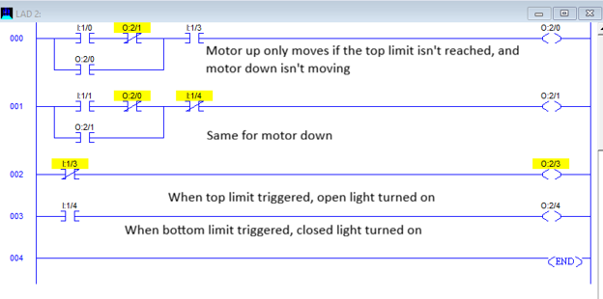
Figure 1: Basic Motor Motions

Task 2
From part 2,

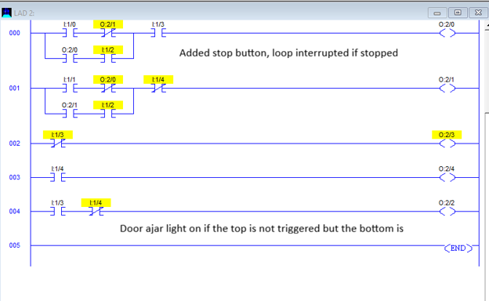
Figure 1: Basic Motor Motions

Task 3
From part 3

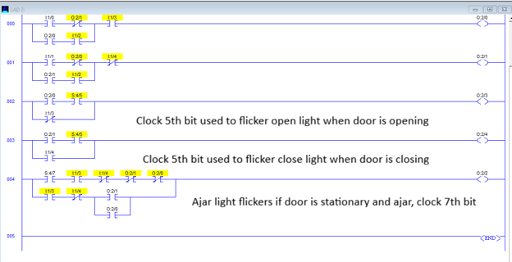
Figure 1: Basic Motor Motions

Conclusion
Conclusion goes here and is more than a few lines…

